6556 JOHNSON DR., MISSION KS. 66202 (913) 432-4780, Fax (913) 262-2690

You are about to experience the many benefits of a therapeutic massage. To assist us in providing you with the best possible massage experience, please take a few minutes to complete the following questions. The information you provide is strictly confidential and will be used to tailor your massage to your individual needs. Please feel free to ask questions that you might have. Then just sit back, relax and let us do all the work.

Name: ________________________________Today’s Date____________________________

Date of Birth:____________________ Email: ________________________________________

Address:______________________________________________________________________

Phone:________________________ Emergency contact________________________________

Profession:____________________________________

If you answer “yes” to any of the following questions, please explain as clearly as possible.

Have you received a professional massage in the past? ⁪ yes ⁪ no
Are you currently under a physician and/or chiropractor’s care? ⁪ yes ⁪ no
Are you being treated for depression/anxiety? ⁪ yes ⁪ no
Do you have diabetes? ⁪ yes ⁪ no
Do you have any contagious disease? ⁪ yes ⁪ no
Do you have osteoporosis? ⁪ yes ⁪ no
Do you have a circulatory problem? ⁪ yes ⁪ no
Do you have any allergies? ⁪ yes ⁪ no
Have you been in an accident or injury? ⁪ yes ⁪ no
Do you suffer from epilepsy or seizures? ⁪ yes ⁪ no
Do you bruise easily? ⁪ yes ⁪ no
Do you have tension or soreness in a specific area? ⁪ yes ⁪ no
Do you have cardiac or circulatory problems? ⁪ yes ⁪ no
Do you suffer from back pain? ⁪ yes ⁪ no

See Reverse

Are you very sensitive to touch or pressure in any area? ⁪ yes ⁪ no
Have you ever had surgery? ⁪ yes ⁪ no
Are you pregnant? ⁪ yes ⁪ no
Do you have any other medical condition? ⁪ yes ⁪ no
Do you have high/low blood pressure? ⁪ yes ⁪ no
Are you taking medication? (list below) ⁪ yes ⁪ no

________________________________________________________________

________________________________________________________________________

Please mark any current problem areas below: (pain, tension, stiffness limited movement)

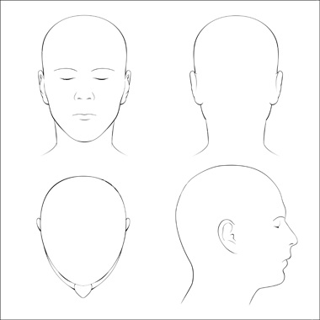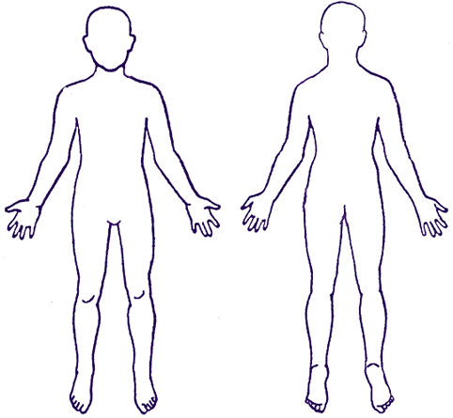

Comments: ______________________________________________________________________________

______________________________________________________________________________

I have provided the above information to the best of my knowledge. I understand that therapeutic massage services are designed to be a health aid and are in no way a replacement for medical care. Information exchanged with the massage therapist is educational and intended to help them become more familiar with your health status and is to be used at my discretion. If I feel any discomfort during my sessions, I will notify the therapist immediately. Any illicit or sexually suggestive remarks or advances, made by me, will result in immediate termination of the session. I will honor my appointments and I agree to cancel 24 hours in advance. I agree to pay the full fee for any appointment missed without 24 hours notice.

Signature:_____________________________________Date:_________________

